Implementation and Design of Secure Instant Messaging

Shuangle Liao
Electricity Engineering
University of Massachusetts, Amherst
Amherst, Massachusetts
shuangleliao@umass.edu

Shihao Xu
Electricity Engineering
University of Massachusetts, Amherst
Amherst, Massachusetts
shihao@umass.edu
Yangjing Liu
Electricity Engineering
University of Massachusetts, Amherst
Amherst, Massachusetts
yangjingliu@umass.edu

Abstract—Instant messaging is a significant part of our life. It is the most convenient way for us to chat with friends, communicate with parents, and exchange information of work and study. But your messages sending in the Internet without enough protection are full of vulnerabilities and risks. They might be wiretapped, modified or counterfeited by third parties. Since the privacy is so important and messages are so sensitive, we need a series of security mechanisms to secure instant messaging in different network layers. The implementation described in this paper is designed in application level and provides integrity, authentication and confidentiality for instant messaging. That means the client can be sure whom he is talking with and received messages are private and same as origin. Authentication is provided by using CA(Certificate Authority) and digital signature. Integrity is provided by digital signatures. And Confidentiality is provided by RSA and DES algorithms.
Keywords—Instant Messaging, Security, DES, RSA, Certificate Authority, digital signature

Introduction
Instant messaging(IM) means all kinds of services which could provide instantly Internet message transfer. It has become extremely rich in functions, such as email, blog, music, television, games and search and other functions, and developed into a kind of an integrated information platform rather than just a simple chatting application. So, people intent to receive and send more and more information through instant messaging apps [1]. Consequently, security of instant messaging has gradually become a wide-range issue, which also might involve criminal actions. Instant Messaging Security Threats include ID theft, privacy threats, virus, etc. In general, there are approximately three key elements of message security on the Internet. They are authentication, confidentiality, and integrity [2].
Through this project, we want to be more aware of the practical risks in networks and the secure framework of network communication. In our mind, the most important purpose about this project is implementing a client-server architecture application with an ability to resist some kinds of security attacks. That is why we focus on not only building a correspondent architecture, but also making the communication messages between entities secure.
First thing we should do to secure the communication is to certify who we are talking to, which means authentication implements. In order to keep our communication secret, we use algorithms and keys to hide information, and also keep the key unknown by unauthenticated entities. What’s more, people need to make sure that their messages are not modified during transferring, so we came up with digital signature [3]. Consequently, instant communication security is not only creating useful programs, but also guarding against cunning, professional people seeking for illegal harvest.

Background and Signiificant
Secure instant messaging application is a system that provides encrypted communication capabilities. Under this system, we can achieve secure information transmission between clients and server by preventing eavesdrop, modification of messages and masquerade attack. Many algorithms and the principles of trustworthy computing are applied to this system, such as DES, RSA and MD5 [4].
After a detailed discussion we have decided to use RSA algorithm for authentication and key distribution, DES(Data Encryption Algorithm)algorithm for message encryption, and MD5 (MD5 message-digest algorithm) for digital signature.

RSA
RSA encryption algorithm is a kind of asymmetric encryption algorithm, and it is widely used in public key encryption and electronic business. RSA is named after Ron Rivest, Adi Shamir and Leonard Adleman. They worked in MIT by the time when it was proposed.
RSA provides a high level of security. The reason is that factorization of maximal integers is extremely hard. In other words, only if the intruder could figure out an efficient way for factorization of maximal integers, RSA encryption algorithm would lose it security quality. Luckily, there is no efficient method to do that by far. Message encrypted using RSA is secure enough if this RSA key is long enough. Because only short RSA key could possibly be decrypted by brute force. That is why we decide to use RSA for authentication and key distribution.

DES
DES algorithm belongs to symmetric encryption algorithms. It was designed by IBM in 1972. Plaintext is divided into several groups, and each group is 64 bits long. Secrete key is also 64 bits long, however, only 56 bits of them would be a part of DES computation, given that there are eight parity bits in the key.
DES also provides high level of security. Because the only way to attack DES encryption algorithm is exhaustive search method, and 56 bits secret key means there are 2^56 of key space, which means about 2285 years is needed for searching if the computer could search 1,000,000 secret keys in one second. However, successfully attack DES algorithm is becoming more and more possible, because of the development of hardware technology and Internet [5]. There are still several shortcomings, such as short secret code lifetime, slow computation speed, and inconvenience result from short block size.

MD5
In 1989, Rivest designed MD2 algorithm. First it supplements data to the message in order to make the length of the message could be divided by 16. And then add a checksum to the end of the message and compute a hash value. Code generated by MD2 algorithm is unique, which means different plaintext would be encrypted into different ciphertext.
Rivest came out MD4 for higher level of security in 1990. MD4 also needs supplement data to make sure the result of message length plus 448 could be divided by 512. However there exist a huge flaw in MD4, it is still cannot be neglected, given that it contributed a lot to other encryption algorithms besides MD5, such as sha-1, RIPEMD, and Haval.
Finally, in 1991, Rivest figured out more sophisticated MD5 encryption algorithm. It adopts a new concept named “safety-belt”, although slower than MD4, which is also a lot safer. MD5 is just slightly different from MD4 in some steps. Except for pseudo-collisions found by Denboer and Bosselaers, there is no other discovered encryption outcome is found in MD5 encryption algorithm. MD5 algorithm has three main characteristics: MD5 ciphertext length is fixed disregard plaintext length. It is quite simple to compute MD5 ciphertext using original message. And it is extremely hard to make any change on the original message, even if it is just one data with same MD5 value, in other words, forgery of data is impossible [6].

Research Design and Methods
There are basically two major models in our project, one of them is public key and certificate distribution model, and another one is message transmission model. First, we need public key and certificate distribution model to prove the authentication of client A and client B and provide reliable and valid public key for distribution. And then we could use the message transmission model for exchanging public key or digital certificate of each other safely.

Public Key and Certificate Distribution Model
In order to provide reliable and valid public key for distribution, we decide to use following model showed in Figure 1. This figure shows how Certificate Authority (CA) certificate public key of client A and client B check the validity of A’s public key.
In this figure, Client A sends a request which contains its ID and public key to the CA. CA uses MD5 algorithm to hash ID and public key if Certificate Authority believes this information is valid. And then CA encrypts hash value with its private key. CA attaches this code to ID and public key of Client A, and sends this certificate back to Client A.
The next step is that Client A sends its own digital certificate to Client B. Then Client B decrypt this certificate with public key of Certificate Authority and getting ID, public key of Client A, and the hash value. To determine the valid of the ID and public key, Client B uses MD5 algorithm to hash same information which was hashed by CA and getting another MD5 code of information of Client A. Client B could make sure whether the identity of Client A is same as the data in CA through comparing these two pieces of MD5 code. As the CA is a trusted server in our system, Client B can make sure it is safe to use this public key of A for future communications.
The distribution of public key from Client B to A is the same way.
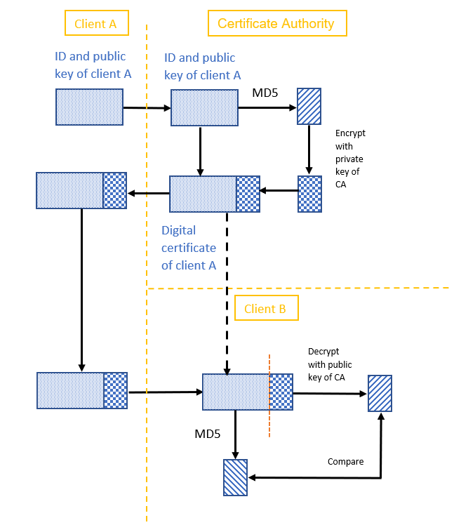
Fig.1. Public Key and Certificate Distribution Model

Message Transmission Model
We use hybrid encryption to implement following message transmission model. This model in Figure 2 assumes that Client A and Client B already have public key of each other, and shows that Client A sends secure messages to Client B with its digital signature.
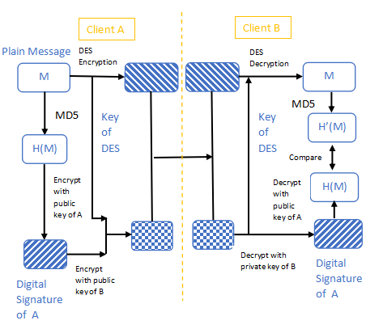
Fig.2. Message Transmission Model

This figure shows only one message sent from Client A to Client B.
Client A encrypts plaintext with DES encryption algorithm to get ciphertext of the message. Then A hashes plaintext with MD5 algorithm and encrypted outcome with its private key to generate a digital signature. And then Client A encrypts DES key and the digital signature with public key of Client B, and attaches this code to ciphertext. A sends ciphertext and attached code together to B.
Client B decrypts the attached code with its private key and gets DES key and digital signature of A. Then B uses this DES key to decrypt the received ciphertext and getting the plaintext. However, the plaintext might be invalid. Thus, Client B hashes this plaintext with MD5 algorithm to generate a MD5 value. In the meantime, B decrypts the digital signature of A with public key of A to get another MD5 value. Now, B could check if this message is valid by comparing the two MD5 value.

Implementation Details
The system is designed with Python 2.7. It is implemented as client-server architecture: two clients apply certificates from CA and communicate through communication server. The CA will output the certificates for clients. After public key distribution, two clients will be able to exchange instant messages. From the communication server we can monitor all exchanging messages between clients.

CA.py
This program runs as the Certificate Authority in the system. It is a multi-thread server which replies certificates to incoming requests (the request contains client’s ID and public key). Depends on the incoming request, MD5 message digest algorithm will be used to produce a 128-bit hash value and the value will be encrypted with CA’s own private key. The result is the certificate for the client. The certificate can only be decrypted by CA’s public key.

chattool.py
This program is the body of clients and communication server. It contains a GUI(graphical user interface) which is implemented with wxpython wrapper. On the GUI, users can complete all operations for the system, that includes determination of role, application and distribution of certificates, and exchange of messages.
If you choose "I am the Server", the program will run as the communication server and open its socket for connections of clients. Its interface will show connection sources of clients and monitor all passing information. However, all messages passed are ciphertext and server cannot decrypt them. It gives us a intuitive view of attackers in the mid and we will involve it in attack tests later.
If you choose "I am a Client", the program will act as a client and connect with running server’s socket automatically. The "Apply certificate" and "Switch Certificate" buttons make the client sends request to CA and distributes its received certificate to another client. Now two clients can exchange messages with the text box and “Send” button. Encrypted message and digital signature will pass the communication server and then reach to another client.
The client will identify the incoming messages and take different reactions depends on them. If received message is the certificate from another client, the client will apply MD5 algorithm to peer’s ID and public key. By comparing the outcome value to the decrypted certificate, it knows whether peer’s public key is valid or not. If the incoming message is ciphertext of message, the client will apply appropriate decryption algorithm to it.

crypto.py
This program contains cryptography used in communication part. It calls MD5, RSA, DES algorithms and provides specific encryption, decryption function for messages.
Encryption involves three parts: encryption of plaintext via DES, generation of digital signature, and encryption of digital signature and DES key. Digital signature will be encrypted by own private key first and then be encrypted with DES key by peer’s public key.
Decryption involves three corresponding parts: decryption of digital signature and key; decryption of ciphertext via DES; and comparation of hash values. If the hash value of the retrieved plaintext is different from the information decrypted from digital signature, the message will be discarded.

Evaluation
Evaluation of our implementation is divided into two parts: normal mode and defending attacks. In normal mode, the system runs in identical environment and its performances will be evaluated. For defending attacks, we will simulate some situations of internet attacks and analysis whether the system can defend these attacks. Detailed steps for these evaluations will be attached in appendix.

Normal Mode
The running of the system is stable and smooth. CA can
provide valid certificates. Two clients can receive messages from each other correctly. From server interface, we can monitor all exchanging packets.
Fig. 1. Client Interface after receiving two same messages
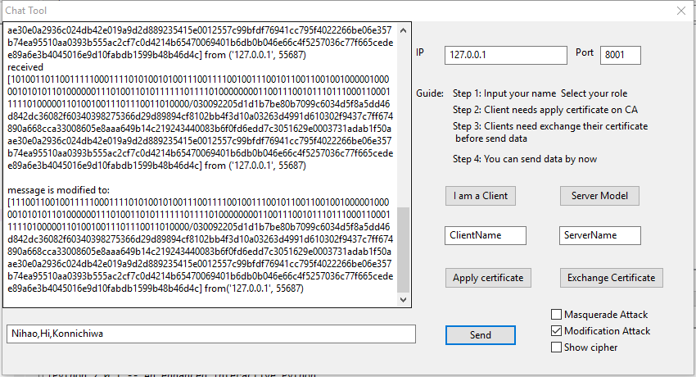

Figure 1 shows the interface of client when it receives an information from another client. For convenience of evaluation, we let it shows both ciphertext and plaintext. The number parts of the ciphertext is encrypted from the message, the rest part is encrypted from digital signature and DES key.
By the speed advantage of DES algorithm, sending longer text does not show obvious increment of latency. The rapid updates of DES key makes the ciphertexts for a pair of same messages are different. That ensures the attackers cannot get part of plaintext from easy analysis.
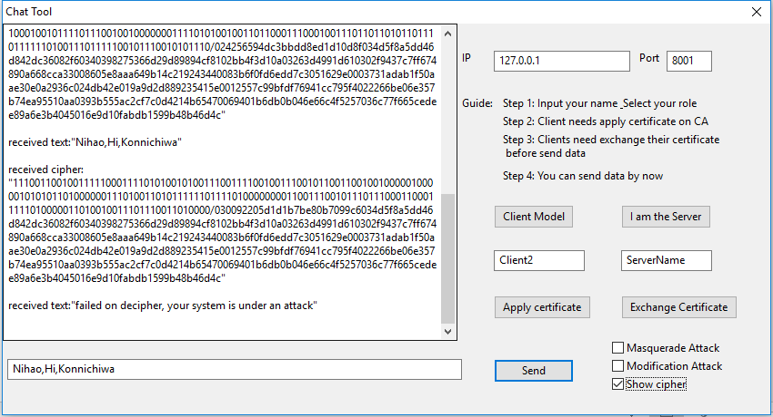

Defending attacks

Release of message contents:
The release of message is the most common passive attack in internet. By eavesdropping the plaintext or compromising the encryption algorithm, attacker can get sensitive and confidential information. In our system, this attack is defended by use of RSA and DES algorithms. All information can be eavesdropped from our system is the messages monitored by communication server. As shown in Figure 2, all these messages are well encrypted by DES or RSA algorithm. So, the security of these two algorithms is the security of our system to defend the release of message contents.

Modification of Message:

Modification of message is simply means that some portion of a legitimate message is altered, or that messages are delayed or reordered, to produce an unauthorized effect.[1] In our system, any modified message should be detected by the client and reply cerresponding error message.
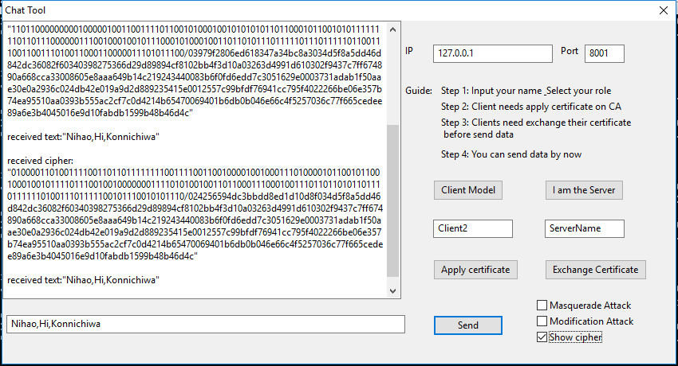

Fig. 2. Server Interface after enabling Modification Attack

In order to simulate modification attack, we change the role of the communication server from a relay to an attacker. As shown in Figure 2, by ennabling the “Modification Attack” on server’s GUI, the server will modify several bits at the beginning of the ciphertext. That causes the receiver retrieve wrong plaintext and then cannot calculate equal hash value to decrypted digital signature. Consequently, the received message will be dropped and alarm will occur.

Masquerade:
The Masquerade takes place when one entity pretends to
be a different entity.[2] In our system (assume client 1 and 2 are authenticated users and client 3 is attacker), if client 3 steals the certificate of 1, and then connect with client 2 by claiming he is client 1. Client 2 should detect the masked identity of client 3 and alarm. To simulate this situation, we can simply tick “Masquerade Attack” on interface of client 1. Now client 1 will not be able to use its original private key (same as the attacker). However, it still can send message to client 2. Client 2 will find the information retrieved from the digital signature is wrong. Thus, it will detect the attack and alarm as shown in Figure 3. Even if client 2 ignores the alarm and send messages back, the messages cannot be seen by attacker.
Fig. 3. Client 2 Interface after Client 1 enabling Masquerade Attack

Future Directions
To design a totally secure instant messaging application in the future, we need to analyze limitations of our implementation. The first point is the CA should be trustable. If the CA is compromised, Masquerade Attack cannot be detect. Ans our system is weak or unresponsive to following attacks.

Traffic Analysis
Traffic Analysis is another type of passive attack besides release of message contents. The opponent could determine the location and identity of communicating hosts and could observe the frequency and length of messages being exchanged. This information might be useful in guessing the nature of the communication that was taking place.[2] To defend this type of attack, the commonly used technique is packet padding. By padding all packets to same length, real length of packets will be hidden from analyzers. Unfortunately, this technique will also cause some overhead for each message. But in instant message, padding bits will not be so long, so packet padding might be useful.

Denial of Service
The denial of service prevents or inhibits the normal use or management of communications.[2] As our server does not provide access control, any client connected to server might be able to broadcast information to all connected clients. If number of these useless messages are too large, that might causes the server shuts down or client interfaces show many useless messages. One way to defend this kind of attack is access control. By use of login system or more advanced protocols (e.g. Kerberos), only authenticated users can connect with server and use the service of Instant Messaging.

Brute force Attack
Although DES algorithm does not have obvious weakness, it is not very safe under Brute Force Attack of high speed computer nowadays. Because the DES key length is not long enough. Better algorithms can overcome the threaten of Brute force Attack, such as 3DES and AES. However, DES key is updated for each message in our system. That makes attackers nearly impossible to compromise all DES keys in our system.

Appendix

Implementation Guidline
Here we provide detailed guideline for installation and evaluation of our implementation on Windows 10 OS.
Installation:

Install Python 2.7.15 and set system environment appropriately.

Download wxpython wrapper.
Evaluation of Normal Mode:
- Open four cmd prompts, run CA.py first then open three GUI by running chattool.py in other three cmd prompts.
- In the first interface, click “I am the server”. In other two interfaces, change the client names and click “I am a client”. After the server show two new connections, the whole architecture is constructed, and all functions are ready to run.
- In clients’ interfaces, click “Apply certificate”. If you get certificate smoothly from the CA, “You got certificate” notifications will appear. Clients’ consoles will show the detailed information of certificates.
- Then click “Exchange Certificate” separately on two clients’ interfaces. That causes the opposite receiving your own certificate. If certificates are checked to be valid, “certificate received” notifications will appear, and the system is ready for message exchanging.
- Now you can choose one client and type any alphabet, number or symbol in the textbox. Click “Send”, your typed information will appear on the screen of another side. Ciphertext can be enabled from client interfaces or be monitored from server’s console.
Evaluation of Defending Attacks:
- To enable Modification of Message Attack, just tick “Modification Attack” on the interface of server. Now try to send message from one client to another. You can see the original information and modified information from server’s console. Another side will detect the error and show “failed on decipher, your system is under an attack”.
- To enable Masquerade Attack, just tick “Masquerade Attack” on interface of one client. Then send any message to another client. Form the server console, you can see all message are still encrypted and seems good. But the receiver will just show “failed on decipher, your system is under an attack”. If you try to send message from another (let attacker performs receiver), the interface will show “you are not a trusted user, you cannot see the message”.

References
- John W. Rittinghouse, Ph.D.CISM, James F. Ransome, CISM, CISSP, “Instant Messaging Security”, pp. 16, ISBN 1-55558-338-5.
- Yintang Dai, Shiyong Zhang. “Research on instant messaging security”.
- Jack Jiang. “Instant messaging security (II): discuss the application of combinatorial encryption algorithm in IM”.
- Mohamed Hamdy Eldefrawy, Khaled Alghathbar, Muhammad Khurram Khan, Hassan Elkamchouchi, “Secure Instant Messaging Protocol for Centralized Communication Group”.
- Mohammed A. Hameed, Ahmed I. Jaber dr Jamhoor M. Alobaidy, Alaa A. Hajer. “Design and Simulation DES Algorithm of Encryption for Information Security”.
- “Tutorial: write a scalable, fault-tolerant, network chat server and client (Scala).”URL: https://doc.akka.io/docs/akka/1.3.1/scala/tutorial-chat-server.html
- William Stallings, “Network Security Essentials: Applications and Standards”, 4th edition, Pearson Education, Inc., pp. 10, ISBN 13:978-0-13-610805-4
- William Stallings, “Network Security Essentials: Applications and Standards”, 4th edition, Pearson Education, Inc., pp. 11, ISBN 13:978-0-13-610805-4

